FOR IMMEDIATE RELEASE – NEW EXHIBITION SPRING 2025

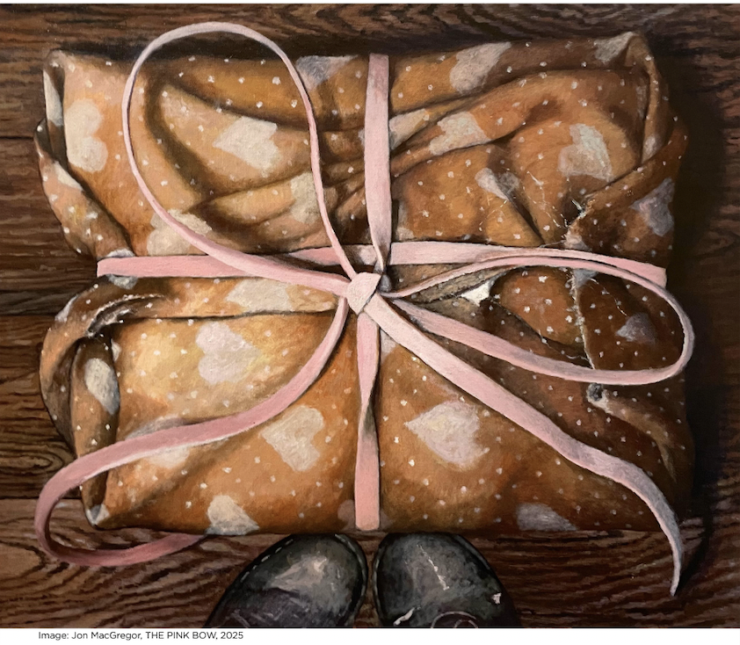

Surprises Unknown: The Art of the Wrapping
Works by 35 artists, classic and contemporary.

Lehman College Art Gallery lehmangallery.org
February 8- May 3, 2025
Reception: Wednesday, February 19, 2025, 5-8 pm, FREE

"Surprises Unknown" Reception Tickets

Artists in the exhibition:
Humaira Abid, Robert Attanasio, Clive Barker, Claudio Bravo, Nick Briggs, Avital Burg, Christo,
E.V. Day, Claudia DeMonte, Paul Fenniak, Janet Fish, Douglas Goldberg, Sarah Hobbs, Leeah Joo,
Ray Kleinlein, Lara Alcantara Lansberg, Saul Leiter, Jane Lund, Jon MacGregor, Jen Mazza, Caroline McCarthy, Sarah McKenzie, Margaret Morrison, Kseniya Oudenot, Frank Paulin, Luanne Rimel, James Rosenquist, Antonio Santin, Barbara Ségal, Jeanne Silverthorne, Diane Smook, Luis Stephenberg, Andy Warhol, William Wegman, and Brenda Zlamany
Works by 35 artists, classic and contemporary, present the art of the wrapping in tempting variety ─humorous, luscious, or doleful⎯─the box crushed, its ribbon shredded. Surprises Unknown: The Art of the Wrapping (on view February 8 through May 3) is a survey of contemporary art that takes as its leaping point the groundbreaking work of Christo and Claudio Bravo and their myriad wrapped projects to look at the thrill of the surprise-to-come that a package brings. What do we feel when we see Ray Kleinlein’s classically polka dot-papered package? Why does E.V. Day mummify Barbie in silvery ribbands, the “last” package? William Wegman conquers the wrapping challenge when he wraps a dog (Game Piece, 2001) as does Jeanne Silverthorne who encases an office chair in bubble wrap and tape (Bubble Wrapped Task Chair, 2016). The package tantalizes, even the ordinary brown Amazon box, which Avital Burg recreates in Box in a Corner, 2013.

Some admire a box’s wrapping, others rip it off, abandoning themselves to anticipation. But there is another side to the package and the real task of Surprises Unknown is not to present ingenious approaches to the art of wrapping but, instead, to unwrap the dichotomy behind a package’s promise of joy and the threat posed by what it conceals. How often does the modern traveler hear “Be aware of the ‘unattended package!’ We can easily swap our curiosity for misgiving as we eye an unopened box.

Wrapping, modern or time-honored, from Japan where it has been an art form for centuries to today where it is a magnet for artists because of its ability to show the figure wrapped⎯fetishized, fascinating or reviled, from mummy to veiled Victorian.

The exhibition is curated by Bartholomew F. Bland and will be accompanied by a 100-page illustrated commemorative catalog.

This exhibition is being made possible, in part, by our generous supporters including the Charina Foundation, Jarvis and Constance Doctorow Family Foundation, Edith and Herbert Lehman Foundation, Keith Haring Foundation, The Pierre and Tana Matisse Foundation, Milton and Sally Avery Arts Foundation, Art as a Third Dimension, New York State Council on the Arts, the New York City Department of Cultural Affairs, and New York City Council Members Eric Dinowitz, Oswald Feliz, Kristy Marmorato, and Kevin C. Riley.

About Lehman College Art Gallery
Always free to the public, Lehman College Art Gallery has been serving the interests of our
diverse audience from the Bronx and greater New York City since 1984. The gallery specializes
in thematic group exhibitions that bring together famous artists with emerging talents.
Education is an integral component of the Gallery’s programming and provides the basis of
community outreach—from young students to senior citizens.

About CUNY
The City University of New York, CUNY, is the public university system of New York City. It is the
largest urban university system in the United States, comprising 25 campuses: eleven senior
colleges, seven community colleges, and seven professional institutions. The system includes
more than a dozen art galleries and centers spread across its campuses.

Contact
Bartholomew F. Bland, Director, Lehman College Art Gallery at Lehman College
Bartholomew.bland@lehman.cuny.edu

